Name : Prerna Singh
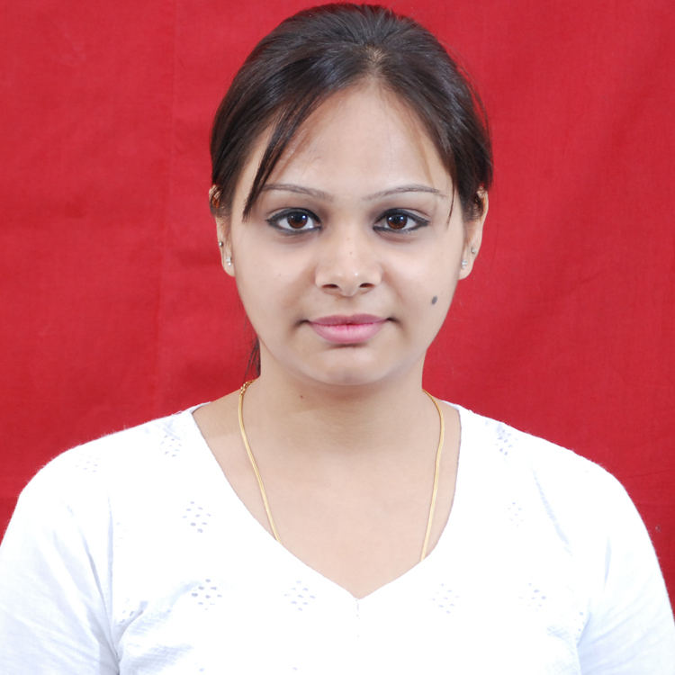

Paste Passport Size Photograph Here

Paste Passport Size Photograph Here
Specialization: Human Resource
Career Objective:
My objective in life is to reach the pinnacle as HR. Professional where I experience the
Satisfaction and enhancement of organizational objectives as well as growth.

Skills Possessed
Computer Skills
- Basic knowledge of Microsoft word, excel & Power Point

- Microsoft Outlook (Basic)
- Digital marketing
Key Soft Skills
- Interpersonal Skills
- Team Skills
- Negotiation Skills
- Self-directed and Organized

Educational Background
Academic Level | Stream | Name of Institution & Board / University | Year of Completion | Percentage (%) | Division
Post-Graduation | Human Resource | Arihant Group Of Institutes/Savitribai Phule Pune University) | Completed | Grade A | 1st
Graduation | B.B.M | Arvind Mahilla College/Magadh University: Patna | 2014 | 64 | 1st
Higher Secondary | Science | Narayani Kanya Vidayalya /Bihar Board: Patna | 2011 | 55 | 2nd
Senior Secondary | All Subjects | Doons Public School /CBSE : Patna | 2009 | 46 | 2nd

Summer Internship
Company’s Name | Project Title | Work Done | Outcome / Achievement | Guide Evaluation  (85) Marks | University Evaluation  ( 300) Marks
Karvy Data Management Service | Recruitment and selection process | - Recruitment /selection  - Generate employee coding  - Employee relation  - Compensation /benefits | - Target achieve  - Recognition

Related Experience:
Company Name- INFINITE VENTURES AND SOLUTION PRIVATE LTD. PUNE,
Designation - Recruitment Executive
Responsibilities –
Handle end to end Recruitment process
Shortlisting resumes based on clients requirement
Scheduling the shortlisted for the interview
Follow up with the offered candidate till their joining date
Company Name - PUNE INSTITUTE OF BUSINESS MANAGEMENT
Responsibilities -
Maintain the faculty’s files
Maintain the students related Data
Oversee Teacher Training
Design Classroom Materials and Curriculums
Analyze Student Performance

Academic Training/Extra Curricular Achievements
- Participated in international seminar on Education & worked as a Coordinator in Patna
- Attended a workshop on “Digital Marketing” in January 2016
- Attended two days Outbound Training on “Leadership Development” in November 2015
- Participated in social & cultural activities in school & college

Personal Details
Hobbies : Trying new recipes, Explore new places
Interest listening music & Dancing
Date of Birth : 20 April, 1994
Languages Known : English, Hindi

Permanent Address House No. 97A Mini LIC Colony, Kankarbagh, Patna
Email-ID prernasingh735@gmail.com
Contact No 7066760735
I, hereby declare that the information given above is true to the best of my knowledge & belief.

Date: 25 April, 2016
Place: Pune Signature:

